Name: Jie MEI Student Number: 1030-29-9698

Homework 3: Interpolation & Numerical Integral

1. Interpolation

In the mathematical field of numerical analysis, interpolation is a method of constructing new data points within the range of a discrete set of known data points. Under my understanding, it aims to approximating the given formula by cutting it into a set of discrete points and find a formula whose graph will pass through this set of points and be closed to the target formula. So with different approximated formula, there are many methods, like Lagrange method and Newton method. At the same time, according different choices of point, we have equidistance nodes and Chebyshev nodes. In order to improving the accuracy of the approximation, we can consider the derivative of each point, which inspires the Hermit method and cubic spline method.

This report shows the graph from using the newton methods with Chebyshev nodes and the cubic spline method with equidistance nodes.

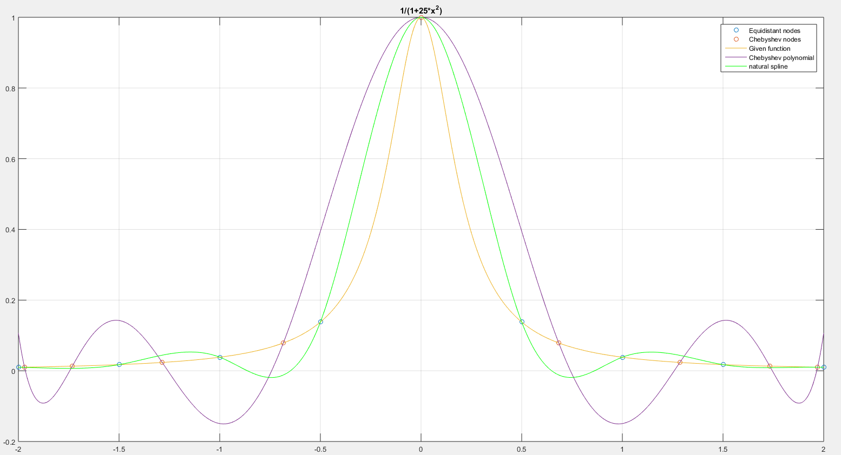

Fig1. Interpolation with the method stated above

|  |  |
| --- | --- |
| Blue notes | Equidistance nodes |
| Orange notes | Chebyshev nodes |
| Yellow line | Given formula |
| Purple line | Chebyshev polynomial |
| Green line | Natural spline |

In order to further compare these two kinds of methods, the error analysis is also done and its figure is shown as followed.

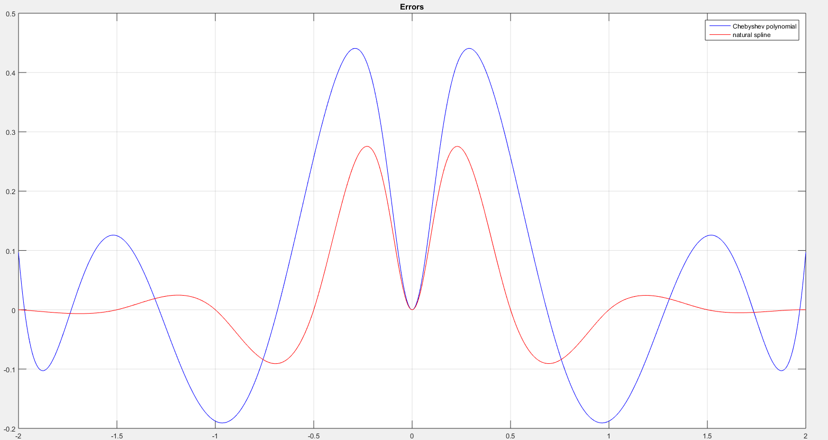

Fig2. Error analysis of the method stated above

|  |  |
| --- | --- |
| Blue line | Chebyshev polynomial |
| Red line | Natural spline |

To conclude, by given a formula $f\left(x\right)= 1/{(1+25×x^{2})}$, this report used two different method to approximate it, the newton methods with Chebyshev nodes and the cubic spline method with equidistance nodes. As you can see, there are nine nodes and eight sections. And from the error analysis, we can imply that, compare to the newton methods with Chebyshev nodes, the cubic spline method with equidistance nodes have lower bias so higher accuracy.

1. Numerical Integral

As the requirement asked, here is the result of the numerical integral with Midpoint rule, Trapezoidal rule, Simpson rule and Clenshaw-Curtis rule in eight order interpolation. At the same time, in order to show the convergence of each rules, the graf with a growing sections from two to eight are drawn as well.

|  |  |  |
| --- | --- | --- |
| Rule | Integral | Error |
| Midpoint | 6.372448212108 | 6.69e-03 |
| Trapezoidal | 6.547297821433 | 1.34e-02 |
| Simpson | 6.389064748550 | 3.48e-06 |
| Clenshaw-Curtis | 6.389056098931 | 5.04e-10 |

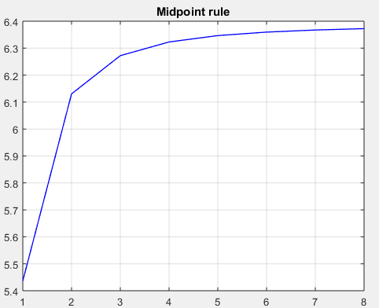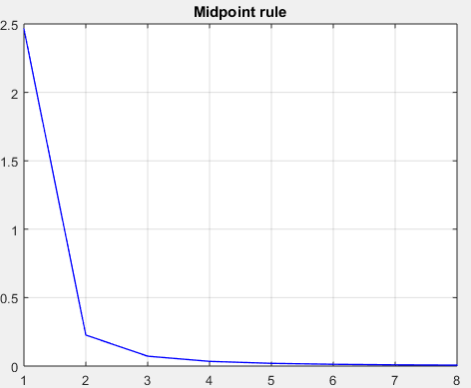

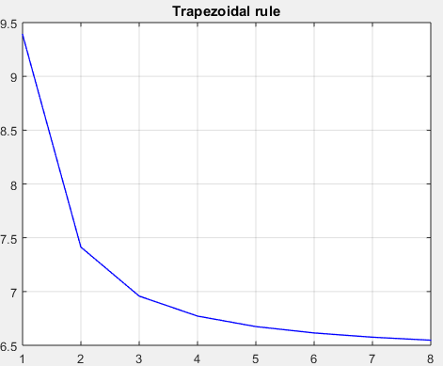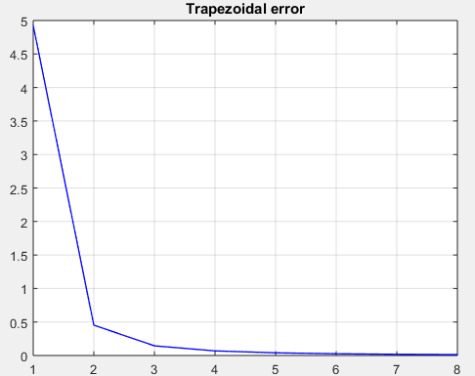

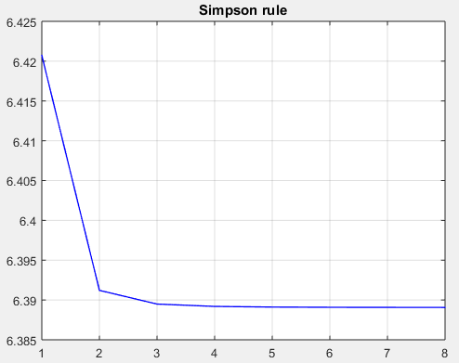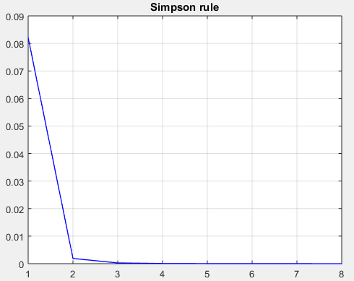

Fig3. Integral value and error analysis of the method stated above

To sum up, the numerical Integral of the formula 1 was calculated in different four rules: the Midpoint rule, the Trapezoidal rule, the Simpson rule and the Clenshaw-Curtis rule.

$I\left(f\right)=\int_{0}^{2}{e^{x}dx}$ (1)

As the partition number increased, we can find out that all the methods will convergent but in different speed and accuracy, in which the Simpson rule has the highest speed and accuracy among the former three rules. And here are the error calculation formulas.

$h= \frac{b-a}{n}$ (2)

$E_{n}^{M}\left(f\right)≈abs[\frac{h^{2}\left(b-a\right)}{12}f^{(2)}\left(γ\right)] γ∈(a,b)$ (3)

$E_{n}^{T}\left(f\right)≈abs[\frac{h^{2}\left(b-a\right)}{24}f^{(2)}\left(γ\right)] γ∈(a,b)$ (4)

$E_{n}^{S}\left(f\right)≈abs[\frac{h^{4}\left(b-a\right)}{2880}f^{(4)}\left(γ\right)] γ∈(a,b)$ (5)

Take the error formula of Trapezoidal rule as an example, we can find out the process of how the error decreases.

$E_{n}^{T}\left(f\right)=\int_{i}^{i+h}{f(x)dx}- \frac{h}{2}\left[f\left(i\right)+f\left(i+h\right)\right]= -\frac{h^{3}}{12}f^{(2)}\left(c_{i}\right)$ (6)

$E_{n}^{T}\left(f\right)= \sum_{i=1}^{n}{-\frac{h^{3}}{12}f^{(2)}\left(c_{i}\right)}$ (7)

$E_{n}^{T}\left(f\right)=-\frac{h^{3}}{12} \sum_{i=1}^{n}{f^{\left(2\right)}\left(c_{i}\right)}=-\frac{h^{3}×n}{12} \frac{\sum_{i=1}^{n}{f^{(2)}\left(c_{i}\right)}}{n}$ (8)

$E_{n}^{T}\left(f\right)≈\frac{h^{2}\left(b-a\right)}{24}f^{(2)}\left(γ\right)$ (9)

From the above calculation, we can imply that the error is depended on the accuracy of the value of the $c_{i}$. If the section number n is large enough, then the range that the $c_{i}$ is pick up from will become smaller then will increase the accuracy at the end. In short, from formula 9, we can imply that with the n increasing, the h will decrease and so as the error, which is roughly proportional to $h^{2}$.